**Case Study on Pizza Sales Dataset**

**DATA VISUALISATON ASSINGMENT-2**

*By-*

**SANSKAR DUBEY**

22201020068

Department of COMPUTER SCIENCE

UNITED UNIVERSITY

RAWATPUR, JHALWA

**BONAFIDE CERTIFICATE**

This is to certify that this project report entitled “**Case Study on Pizza Sales Dataset**” submitted to **UNITED UNIVERSITY, RAWATPUR, JHALWA,** is a Bonafide record of work done by **“SANSKAR DUBEY”** under my supervision from **“15/04/2023”** to **“25/04/2023”.**

**Mr. Kuldeep Gupta**

IBM Trainer & Teacher

*From Department of*

**Computer Science**

PRAYAGRAJ

24/04/2023

**DECLARATION**

This is to declare that this report has been written by me “**SANSKAR DUBEY**”. No part of the report is plagiarized from other sources. All information included from other sources have been duly acknowledged. I aver that if any part of the report is found to be plagiarized, I are shall take full responsibility for it.

SANSKAR DUBEY

22201020068

PRAYAGRAJ

24/04/2023

**TABLE OF CONTENTS**

|  |  |
| --- | --- |
| TOPIC NAME | PAGE NUMBER |
| INTRODUCTION TO THE DATA SETS | 5 |
| CREATING A DATA MODULE | 6-10 |
| Problem Statements | 11 |
| SOLUTION OF PROBLEM STATEMENTS query-1 | 12 |
| SOLUTION OF PROBLEM STATEMENTS query-2 | 13-14 |
| SOLUTION OF PROBLEM STATEMENTS query-3 | 15-16 |
| SOLUTION OF PROBLEM STATEMENTS query-4 | 17 |
| SOLUTION OF PROBLEM STATEMENTS query-5 | 18 |
| CONCLUSTION | 19 |
|  |  |
|  |  |
|  |  |

**INTRODUCTION TO THE DATA SETS**

**Pizza Sales Dataset**

The Pizza Sales Dataset is a fictional dataset commonly used as an example in data analytics and business intelligence courses, including IBM Cognos. The dataset contains information about a pizza chain's sales over a period of time, including details about the pizzas sold, the customers who purchased them, and the stores where they were sold.

The dataset typically includes variables such as:

Date: the date of the sale,

Pizza ID: the ID of the pizza that was sold,

Pizza Name: the name of the pizza that was sold,

Pizza Size: the size of the pizza that was sold,

Pizza Price: the price of the pizza,

Quantity: the number of pizzas sold in the transaction and etc,

Using this dataset, analysts can gain insights into various aspects of the pizza chain's business, such as which pizzas are most popular, which stores are performing best, and which customers are making the most purchases. These insights can then be used to make data-driven decisions that help improve the company's bottom line

**CREATING A DATA MODULE**

**STEPS FOR CREATING DATA SETS INTO DATA MODULE ARE:**

Upload all your data sets files in IBM COGNOS.

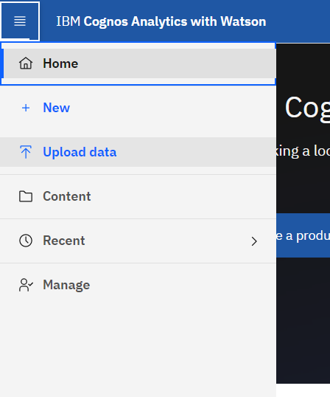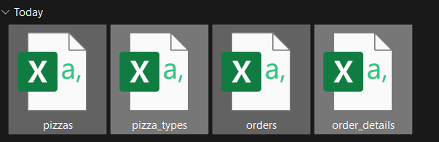

Then select all the uploaded files from MY CONTENT and click on CREATE DATA MODULE.

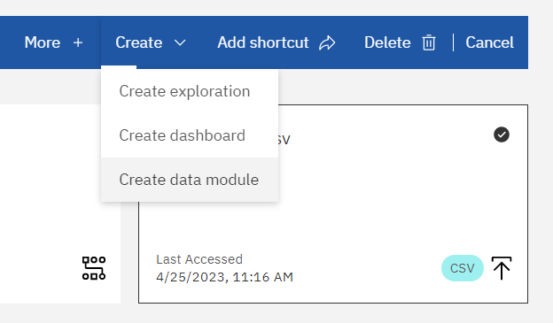

Now built a relationship between your data by connect all the data sets by finding similar column between them in relationship tab match the columns and click on Ok.

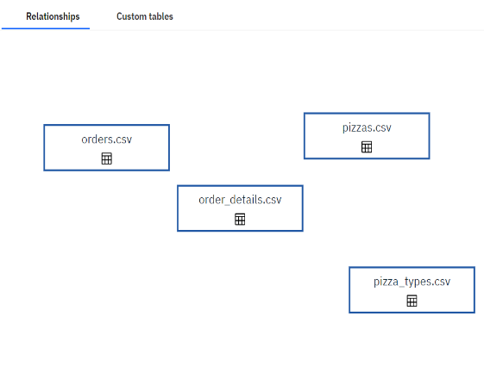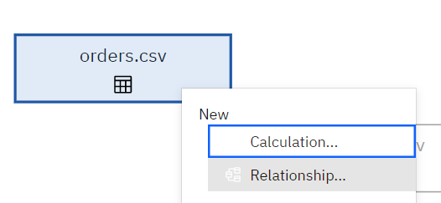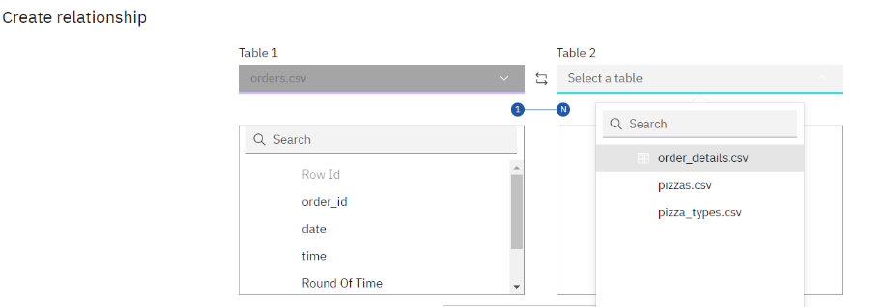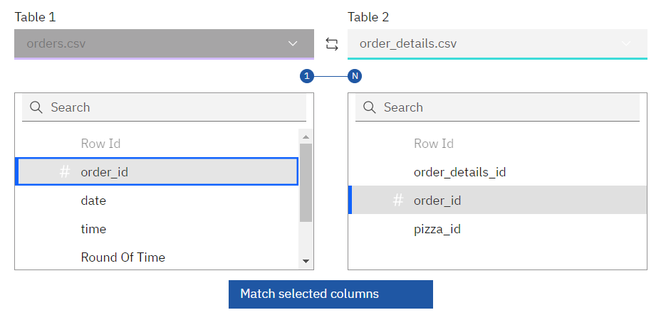

Do the same process with all the DATA SETS after that this sets of data are ready to be used as DATA MODULE in REPORTS and DASHBOARD.

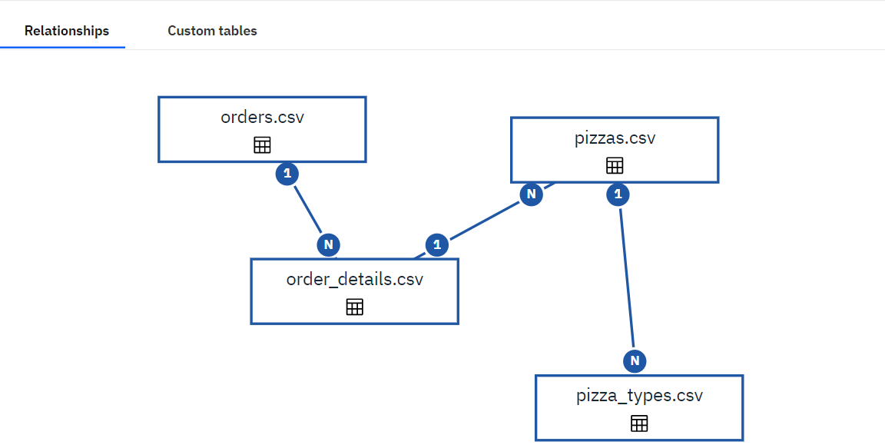

**Some other requirement for dashboard processing:**

**Creating a CUSTOM TABLE**

Select the files from the source of the data module and right click on it.

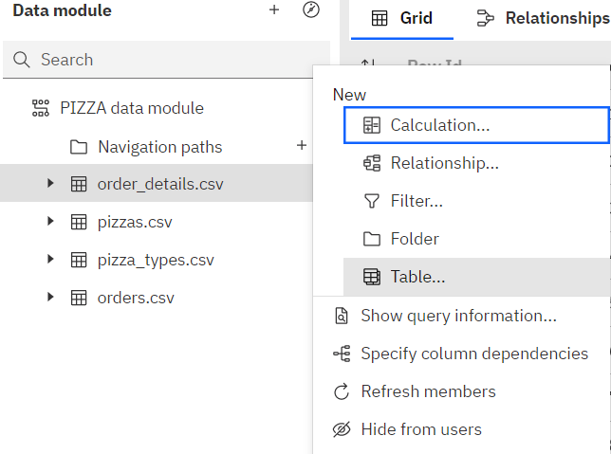

Select TABLES and add other file from FIND (file which you want to create a joint view with), and click on JOINT VIEW and click OK.

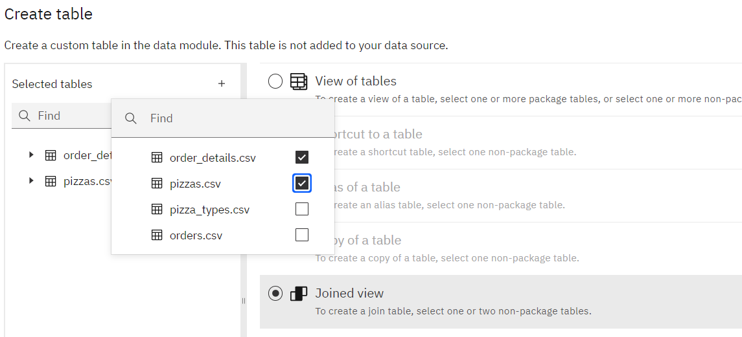

Now your CUSTOM TABLE is created now create the relationship with this table with the other tables as done before.

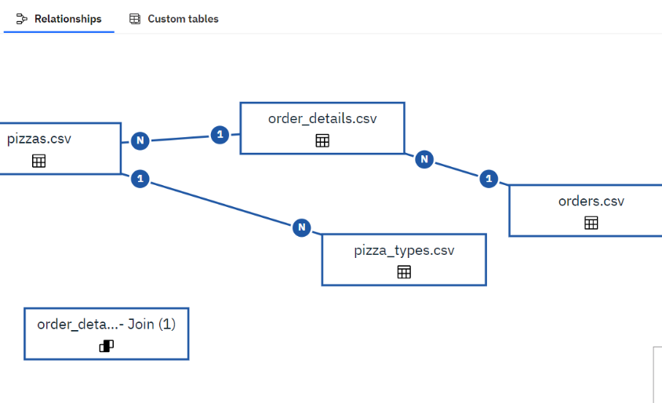

Final view of the tables showing RELATIONSHIP and now you can go to DASHBOARD to use thi custom table directly.

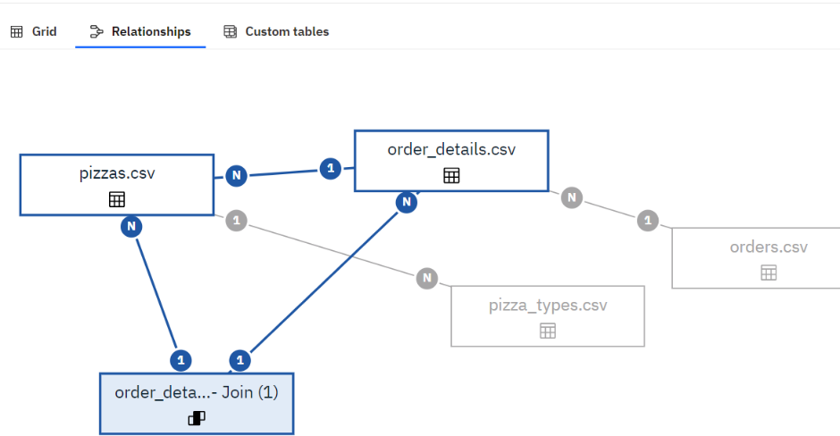

Before you go to the Dashboard, we need some calculation to be done i.e., Total Sales… For that we have right click on the new joint table and select CALCULATION.

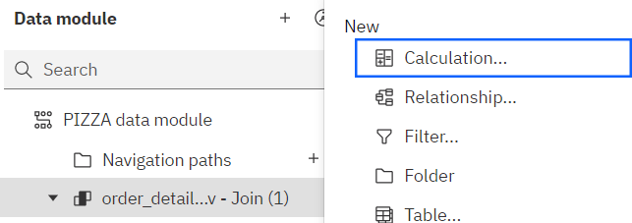

In the Expressions, write the basic Sales formula i.e., **quantity*price**. And click OK.

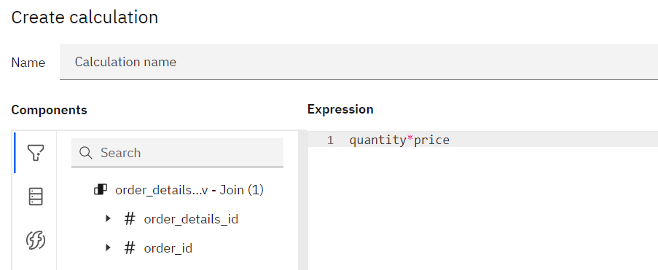

Now we are done with this now we can create reports and dashboard with this DATA MODULE.

**Problem Statements Based on PIZZA SALES DATA MODULE:**

(1) What was the total revenue generated in 2015, organized by month and year?

(2) Create a chart that displays the contribution of each category to total pizza sales.

(3) Identify the weekday with the highest pizza sales during a particular hour.

(4) Create a line chart that illustrates the fluctuation in total sales over the years.

(5) Determine which pizza type was the most popular in the month of June.

**SOLUTION OF PROBLEM STATEMENTS**

**QUERY 1**- What was the total revenue generated in 2015, organized by month and year?

**ANSWER-** DASHBOARD VIEW

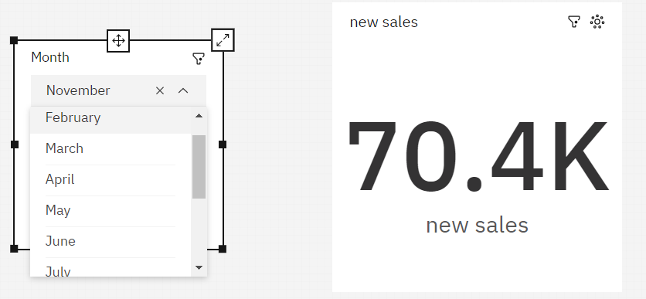

**STEPS-**

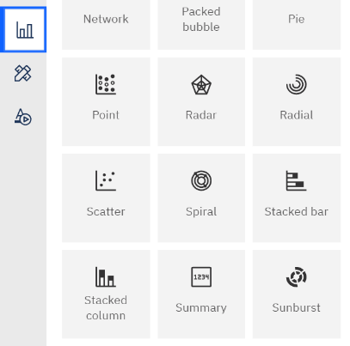 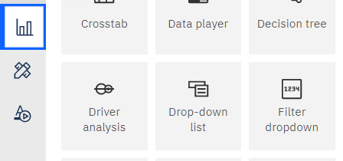

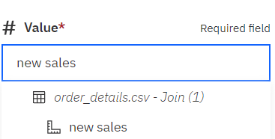 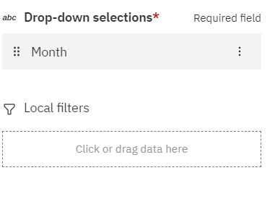

CLICK ON VISUALIZATION> DOUBLE CLICK ON SUMMARY TOOL AND DROP-DOWN TOOL>IN FIELDS OF DROP-DOWN FILL MONTHS AND IN SUMMARY FILL SALES (NEW CALCULATED TABLE CELL).

**SOLUTION OF PROBLEM STATEMENTS**

**QUERY 2**- Create a chart that displays the contribution of each category to total pizza sales.

**ANSWER-** DASHBOARD VIEW

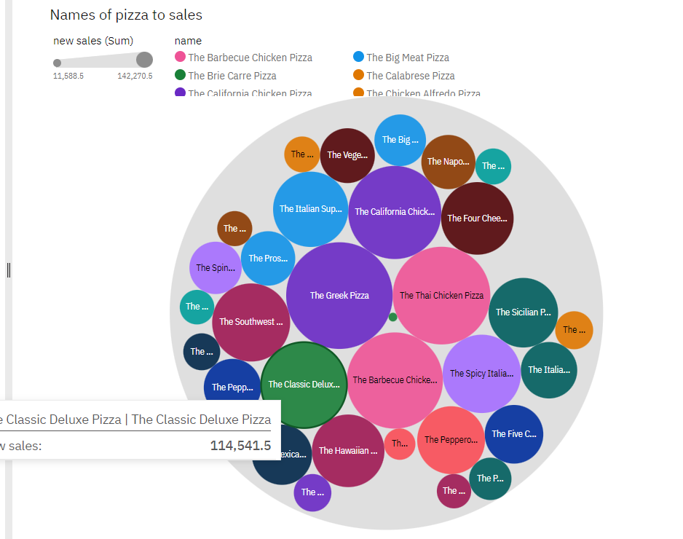

**STEPS-**

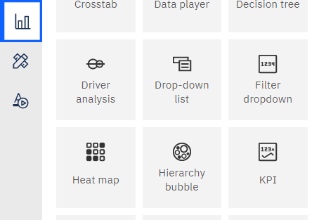 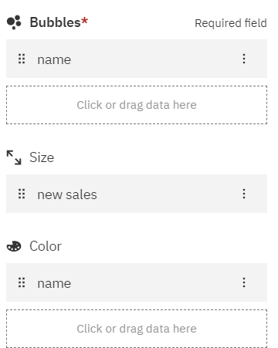

CLICK ON VISUALIZATION> DOUBLE CLICK ON HIERACHY BUBBBLE TOOL> IN FIELDS FILL NAMES IN BUBBLE> SALES IN SIZE AND AGAIN NAME IN COLOR.

**SOLUTION OF PROBLEM STATEMENTS**

**QUERY 3**- Identify the weekday with the highest pizza sales during a particular hour.

**ANSWER-** DASHBOARD VIEW SHOWS THURSDAY, 12 TO 1 PM.

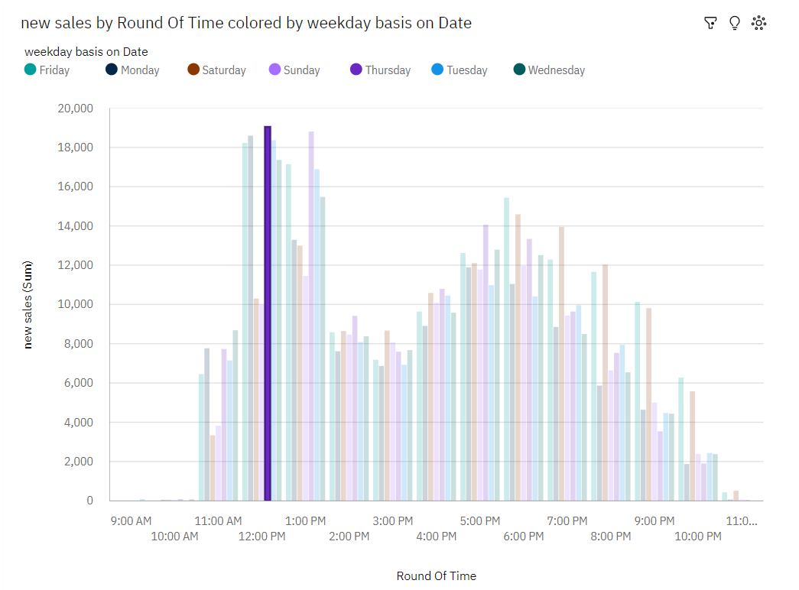

**STEPS-**

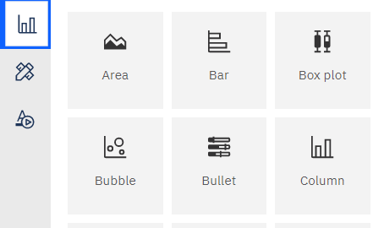

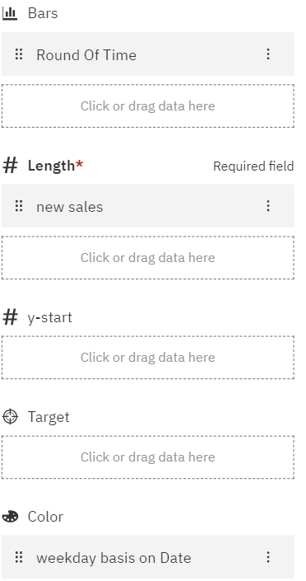

CLICK ON VISUALIZATION> DOUBLE CLICK ON COLUMN TOOL> IN FIELDS FILL ROUND OF TIME IN BARS, SALES IN LENGTH, WEEKDAYS BASIS ON DATE IN COLOR.

**SOLUTION OF PROBLEM STATEMENTS**

**QUERY 4**- Create a line chart that illustrates the fluctuation in total sales over the years.

**ANSWER-** DASHBOARD VIEW

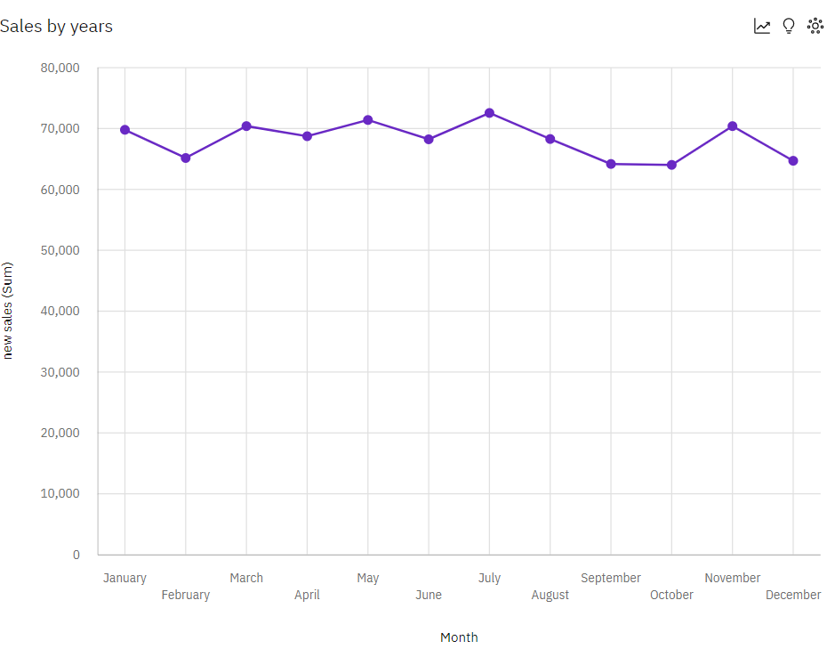

**STEPS-**

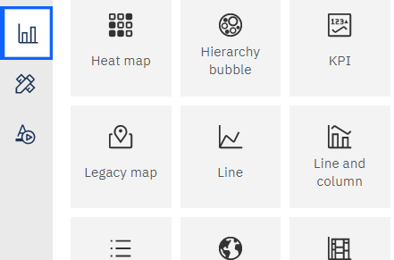 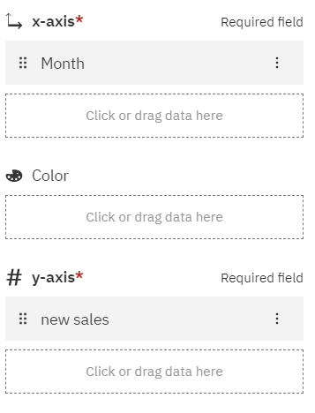

CLICK ON VISUALIZATION> DOUBLE CLICK ON LINE TOOL>IN FIELDS FILL MONTHS IN X-AXIS AND SALES IN Y-AXIS.

**SOLUTION OF PROBLEM STATEMENTS**

**QUERY 5**- Determine which pizza type was the most popular in the month of June.

**ANSWER-** DASHBOARD VIEW

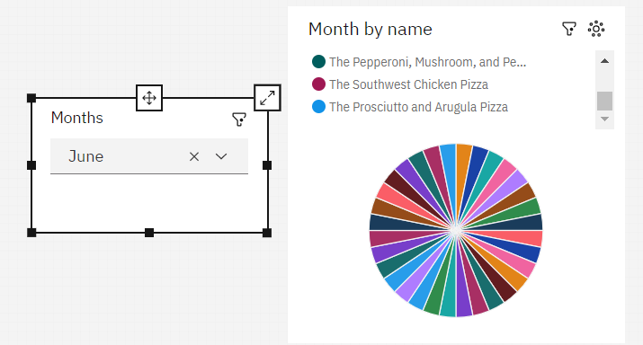

**STEPS-**

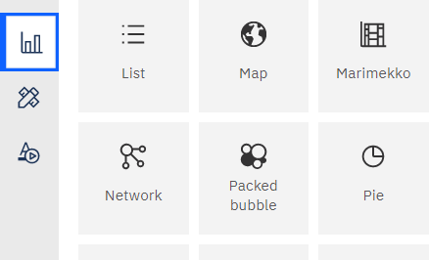 

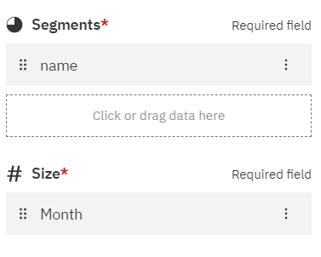 

CLICK ON VISUALIZATION> DOUBLE CLICK ON PIE TOOL AND DROP-DOWN TOOL>IN FIELDS OF DROP-DOWN FILL MONTH AND IN FIELDS OF PIE FILL NAMES IN SEGAMENT AND MONTH IN SIZE.

**CONCLUSTION**

In conclusion, the IBM Cognos data set for pizza sales provides valuable insights into various aspects of the business. The problem statements addressed in this analysis allowed us to gain a deeper understanding of the revenue generated, category contributions, peak sales hours, sales fluctuation over the years, and the most popular pizza type in a specific month.

Firstly, by examining the total revenue generated in 2015, organized by month and year, we were able to identify the financial performance patterns and assess the success of the business during that period.

Secondly, the chart illustrating the contribution of each category to total pizza sales helped us understand which categories played a significant role in driving sales and identify any areas that might require improvement or additional focus.

Thirdly, the identification of the weekday with the highest pizza sales during a particular hour enables the business to optimize its operations by allocating resources effectively and strategically planning promotional activities.

Fourthly, the line chart depicting the fluctuation in total sales over the years provided a visual representation of sales trends, allowing us to identify any long-term patterns, seasonality, or anomalies that may influence future decision-making.

Lastly, determining the most popular pizza type in the month of June allowed us to recognize customer preferences during that specific period and adjust marketing strategies or product offerings accordingly.

Overall, the analysis of the IBM Cognos data set for pizza sales presented valuable insights that can guide strategic decision-making, optimize operations, and enhance customer satisfaction. By leveraging the power of data analytics, the business can refine its strategies, allocate resources effectively, and stay ahead of the competition in the dynamic pizza industry.